Pöttinger launches new FOX 3000 D compact combination
Efficient seedbed preparation for the best working results

Each type of soil requires site-specific preparation with the best match of tillage implement to guarantee sustainable farming and long-term yield. Pöttinger has upgraded its compact combinations so they are even easier to pull and save more fuel. The FOX 3000 D has a neater configuration and the narrow, yet strong headstock improves the view of the machine from the tractor cab. The new hydraulic depth adjustment system is available as an option to enhance operating convenience. Combined with a Pöttinger seed drill, this implement becomes a cost-effective sowing combination.

The best working results
The key feature of the Pöttinger FOX 3000 D compact combination is its design. The lightweight construction, for smaller tractors starting at 80 hp, enables high output and optimum seedbed preparation at the same time.
Because the discs rotate and have a diameter of 410 mm, the machine needs less tractive power and consumes less fuel as result. The soil is intensively loosened, mixed and levelled thanks to the combination of the disc angle and inclination.
The discs on the first row are arranged to face in the opposite direction to the discs on the second row. This configuration ensures soil movement over the full working width. The large row spacing of 510 mm provides excellent clearance, even with high volumes of organic matter. Optional track eradicator tines thoroughly loosen the tractor wheel marks to enable perfect mixing at a consistent working depth.

Cost effective and low draft
FOX 3000 D short combinations can be used flexibly on fields that have been ploughed or stubble cultivated. The discs operate reliably in site conditions with medium levels of organic matter. Because the discs have a small diameter, they rotate at high speed to deliver intensive mixing and a high quality seedbed structure. The short and compact design ensures an optimum centre of gravity, also when used in combination with a Pöttinger implement-mounted seed drill. Ultimately, this machine achieves higher working speeds, smoother operation and lower variable costs.

The advantages of low wear and low draft make the FOX 3000 D compact combination an extremely cost effective all-rounder.

Photo preview:
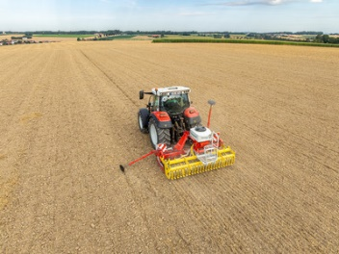 | 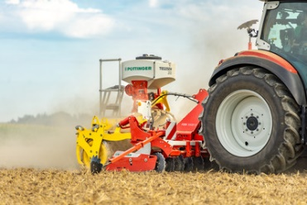
FOX 3000 D: The cost effective, low draft, compact combination | The best working results in seedbed preparation with the FOX 3000 D
https://www.poettinger.at/de_at/newsroom/pressebild/153763 | https://www.poettinger.at/de_at/newsroom/pressebild/153762

More printer-optimised photos: www.poettinger.at/presse

